Working Proposal for a Pilot Collaboration
UMAPS Corralejo • San Miguel de Allende
Dental care, chronic disease management and digital capacity
Proposed collaboration | Salud + Sufi Service Committee Sweden
Initial pilot area | UMAPS Corralejo and surrounding communities (~5,000 inhabitants)
Proposed pilot period | 1–2 years, with evaluation after the first year
Report date | 16 May 2026

1. Purpose and planning approach
This document is intended as a structured working proposal for continued dialogue with Dr. Héctor Adrian Delgado and Salud. The overall concept should be divided into smaller, clearly defined projects, each developed in sufficient detail to visualize expected results, implementation steps, responsibilities, costs and evaluation methods.
The proposal should remain iterative. Each component may need to be reassessed several times from technical, clinical, legal, operational and financial perspectives before a final implementation plan is established.

2. Institutional model
The preferred model is a joint project between Salud San Miguel and Sufi Service Committee Sweden, which collaborates with Fundación Nur in Mexico. Sufi Service Committee Sweden would finance and organize defined parts of the operation, while healthcare activities would be carried out under Salud’s healthcare license, institutional framework, security protocols and overall supervision.
- Salud could review and validate professional credentials and staff documentation, including personnel selected or financed by the committee.
- Salud could ensure that permits, procurement procedures and formal requirements comply with applicable Mexican regulations and national legislation.
- Salud could conduct quality inspections of care, equipment and materials; Sufi Service Committee Sweden would also maintain its own internal quality-control processes.
- A formal collaboration agreement could initially cover approximately 1–2 years, with the possibility of extension or expansion based on results.
The same proposals and protocols were previously presented to Patronato Pro Niños following two meetings. As that collaboration model has not progressed, Sufi Service Committee Sweden is evaluating whether it can finance and organize the proposed activities directly within Salud’s institutional structure.

3. Project A – Dental care pilot

3.1 Stationary or mobile dental unit
Two alternatives should be evaluated before implementation. The first is a stationary dental facility of approximately 40–50 m², built as an extension connected to the existing Salud/UMAPS building. The second is the purchase of an advanced mobile or relocatable dental unit. The final choice should be based on total cost-effectiveness, regulatory feasibility, construction and installation time, expected patient volume, security, maintenance needs and the possibility of serving additional communities. Both alternatives should comply with formal requirements and be equipped for one or two dental chairs and digital intraoral radiography.
If a mobile or relocatable unit is selected, it could initially be placed within the UMAPS Corralejo area. After approximately 6–12 months, Salud and the project partners could decide whether it should remain in Corralejo, be relocated to another UMAPS according to regional need, or be supplemented by a second unit in another area. If the stationary alternative is selected, a similar facility could later be built at another UMAPS if the pilot demonstrates sufficient demand and good results. Salud will prepare the necessary technical drawings, site plans and construction or placement documentation and submit the project to the relevant Dirección de Planeación (Planning Directorate) and other authorities for evaluation and possible approval.
- Stationary option: approximately 40–50 m² connected to the existing Salud building, with durable infrastructure and the possibility of long-term use.
- Mobile or relocatable option: faster deployment and greater flexibility, subject to transport, utility connections, security and maintenance requirements.
- Decision basis: comparative total budget, permits, installation time, expected utilization, operating costs and potential regional reach.
- Illustrative mobile/capsule reference: https://www.facebook.com/share/r/18KvgpkHBU/
Illustrative concept for a prefabricated modular capsule building connected to an existing Salud facility
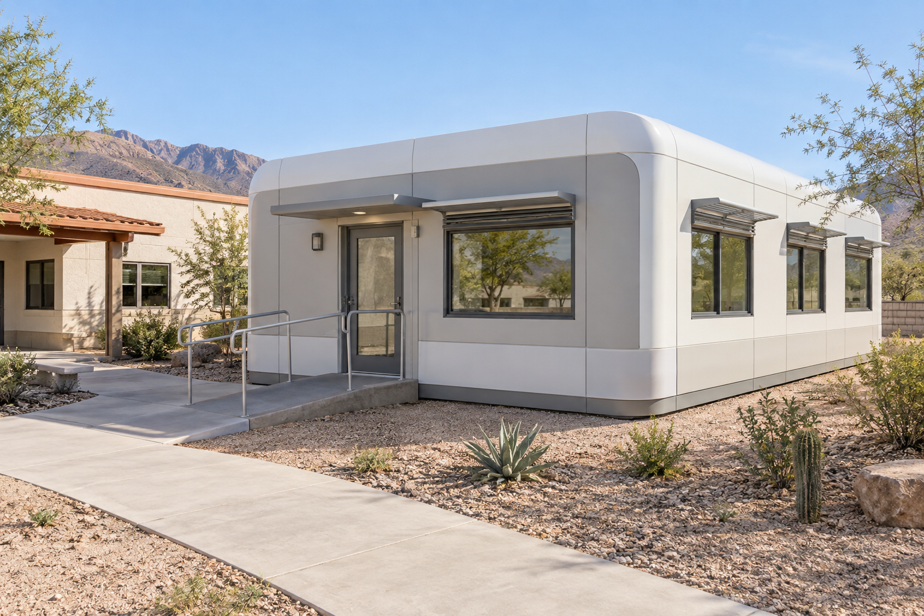
Illustrative concept only; final design, materials, utilities and site connection require Salud’s technical and regulatory approval.
Illustrative preliminary floor plan for a compact 49.5 m² dental facility with one or two treatment rooms
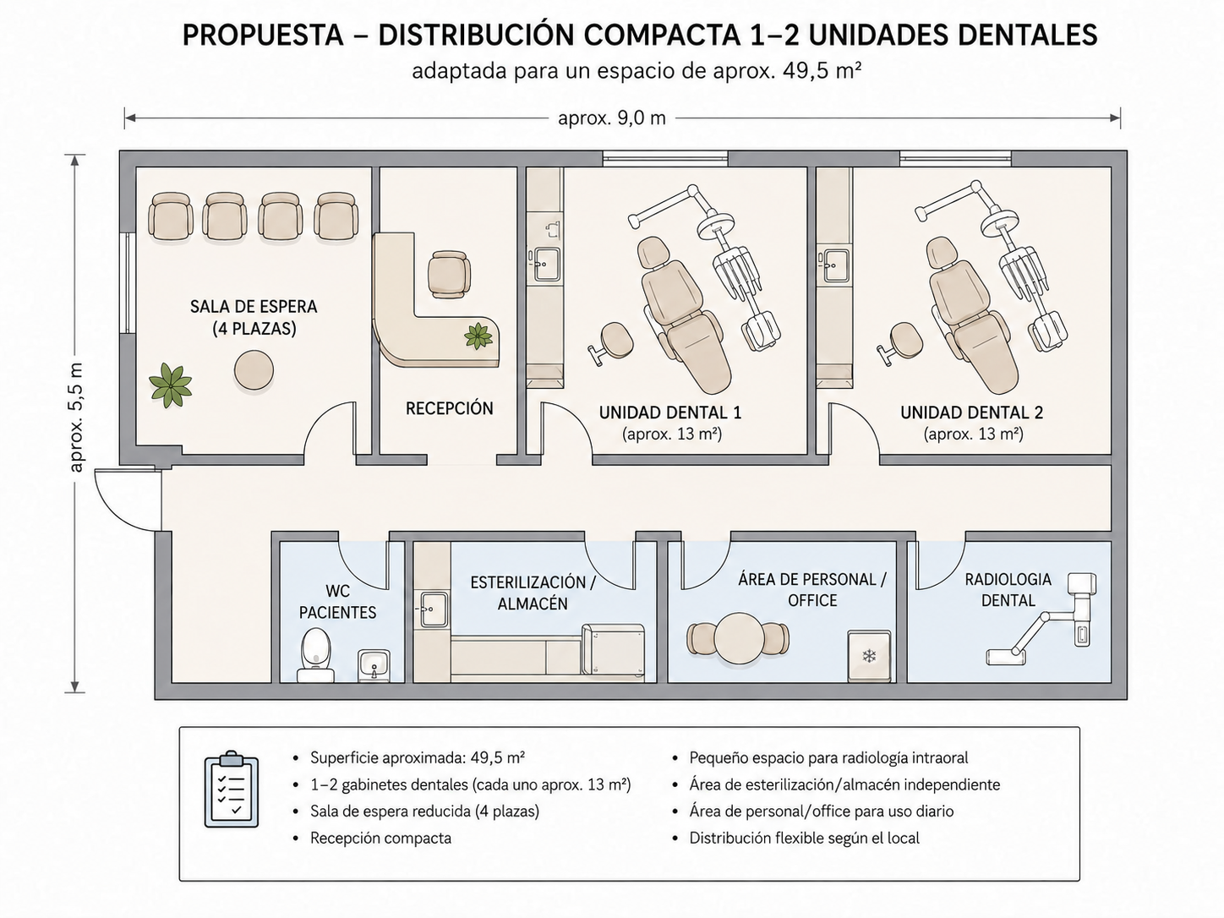
The sketch is a planning reference only. Salud’s technical team will adapt dimensions, access, utilities, infection-control flows, radiology protection and accessibility to the selected site.

3.2 Preliminary equipment and digital communication
The following items are preliminary product categories and examples for budgeting. Final models must be selected jointly with Salud and verified for Mexican technical, electrical, radiological, infection-control, warranty and procurement requirements.
- One or two complete dental treatment units/chairs, including operating light, delivery system, suction and clinician stool. Product reference supplied for comparison: https://www.alibaba.com/x/1lB4dZo?ck=pdp
- One adjustable examination/treatment couch for assessment or procedures when a dental chair is not appropriate. Product reference supplied for comparison: https://www.alibaba.com/x/1lB4duM?ck=pdp
- Digital intraoral radiography equipment, sensors, protective equipment and an approved image-storage workflow.
- Sterilization and infection-control equipment, including an autoclave, instrument storage, handwashing facilities and appropriate clinical waste containers.
- Height-adjustable electric work desk, approximately 120–160 × 60–70 cm and 73–118 cm in height, or an equivalent locally sourced model.
- All-in-one computer with a large screen, approximately 27 inches, together with keyboard, mouse, secure network access and backup arrangements.
- Large television or interactive display with camera, microphone and speakers, plus a simple audio system, for remote clinical meetings, education and contact with the Swedish team.
- Indoor and/or outdoor security-camera system with local management by Salud; a solar-powered Wi-Fi camera is one possible example where cabling is difficult.
- Reception furniture, lockable storage, ergonomic staff chairs, new waiting-room seating and basic office equipment. Where feasible, replacing worn furniture and equipment with clean, modern items would refresh the working environment, improve ergonomics and practical function, and may also strengthen staff wellbeing, pride and motivation.
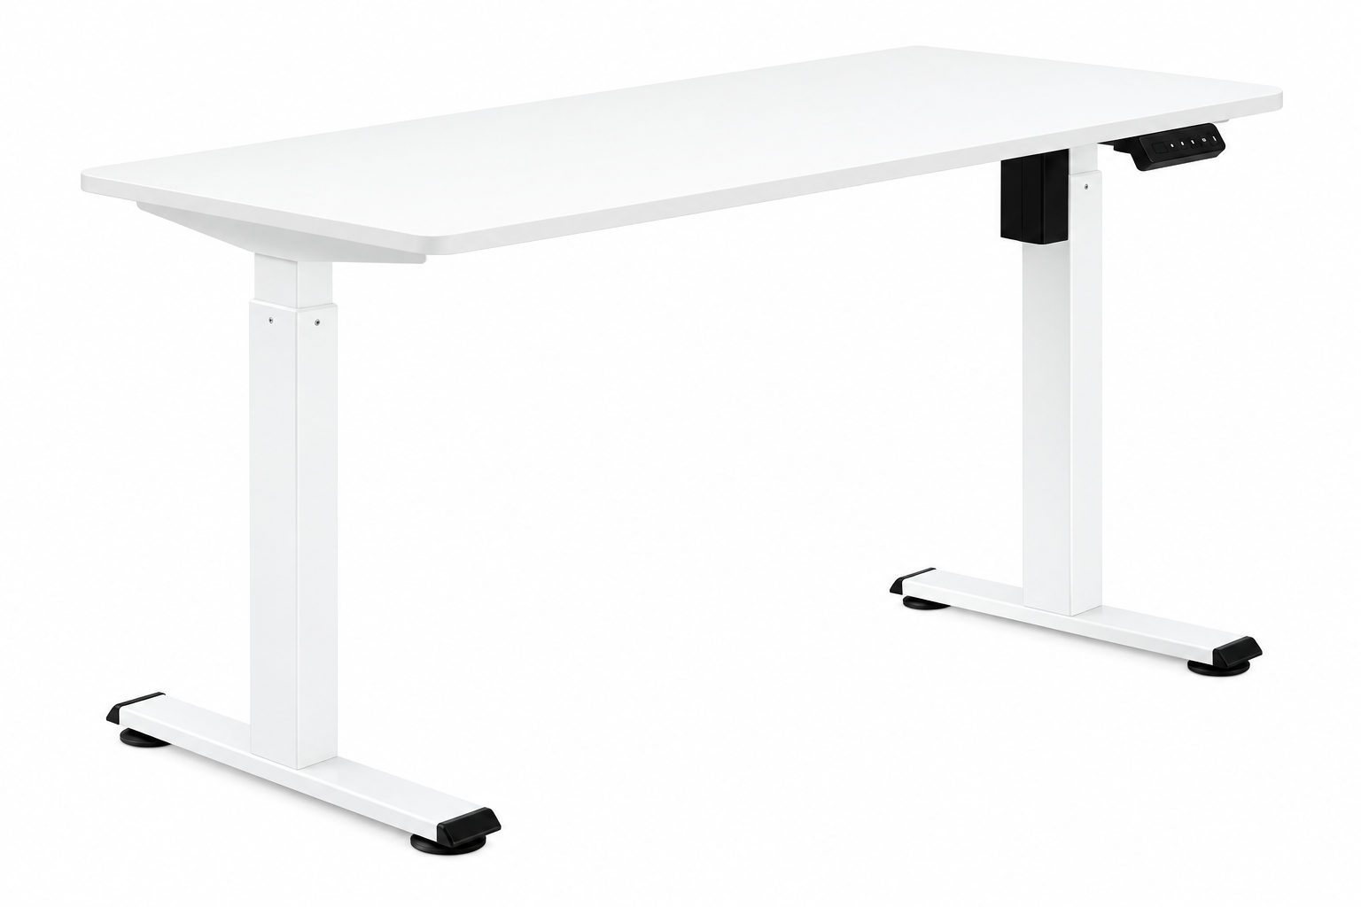  Example of an electric height-adjustable desk |   Example of a 27-inch all-in-one computer
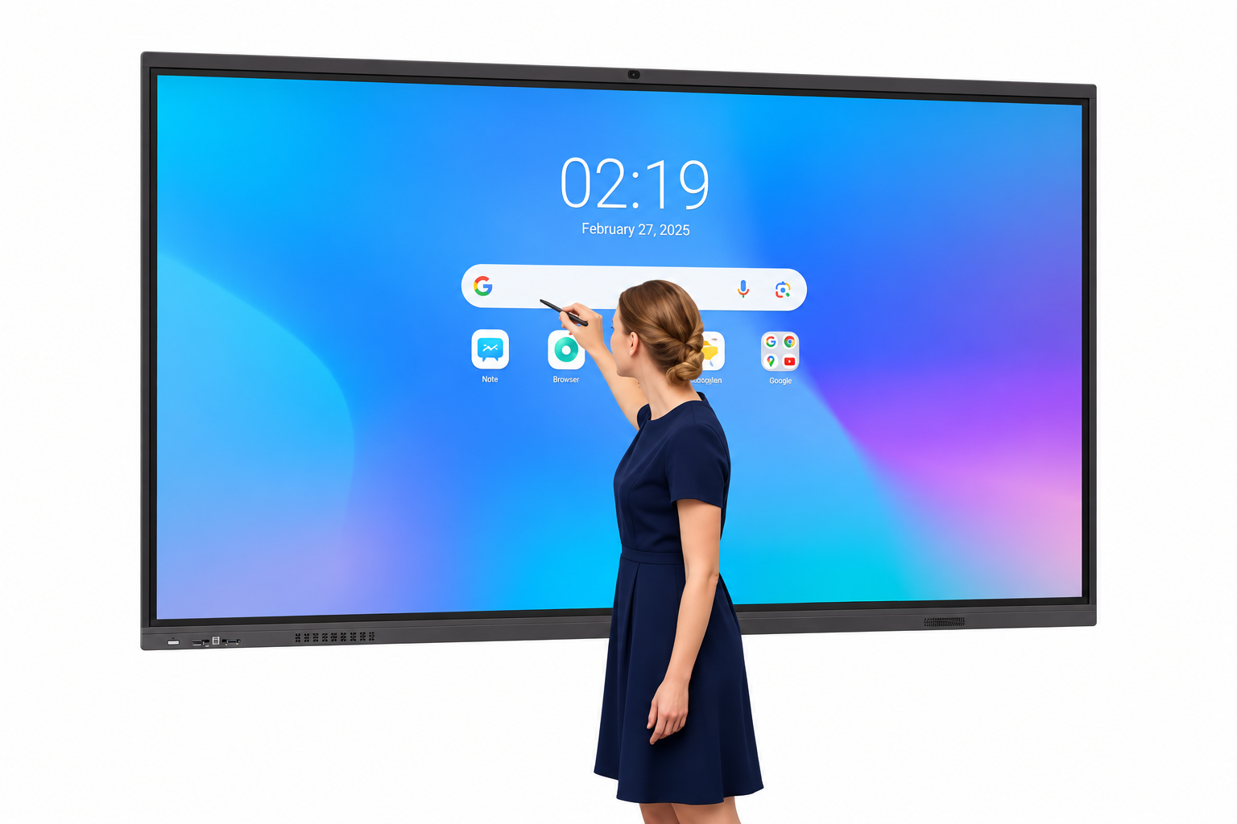  Example of a large interactive display for remote contact | 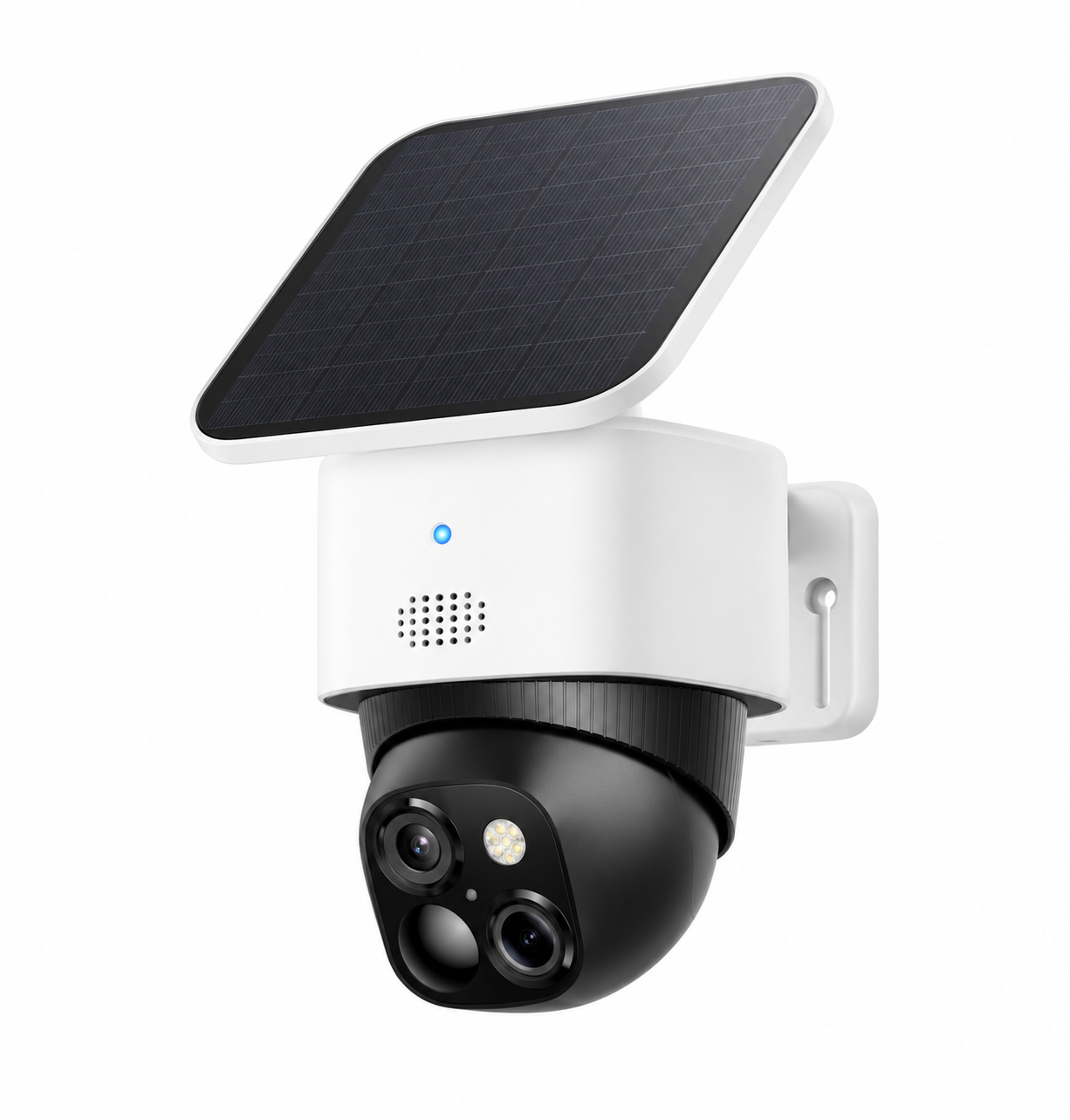  Example of a solar-powered Wi-Fi security camera
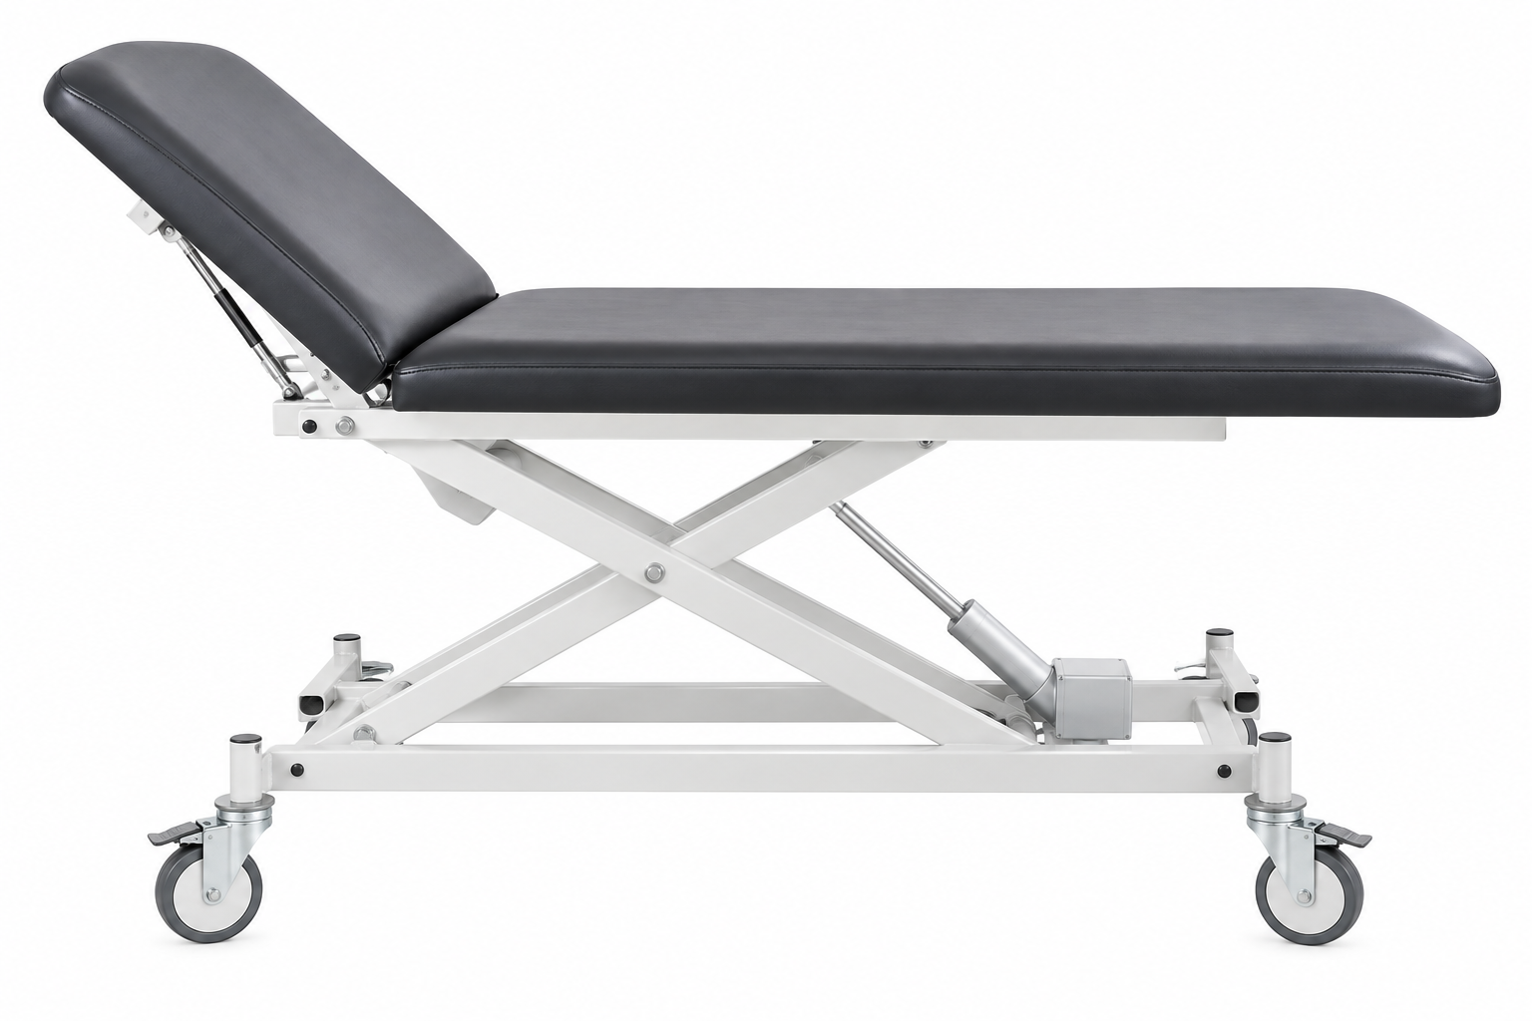  Product reference for an electric two-section examination and treatment couch | 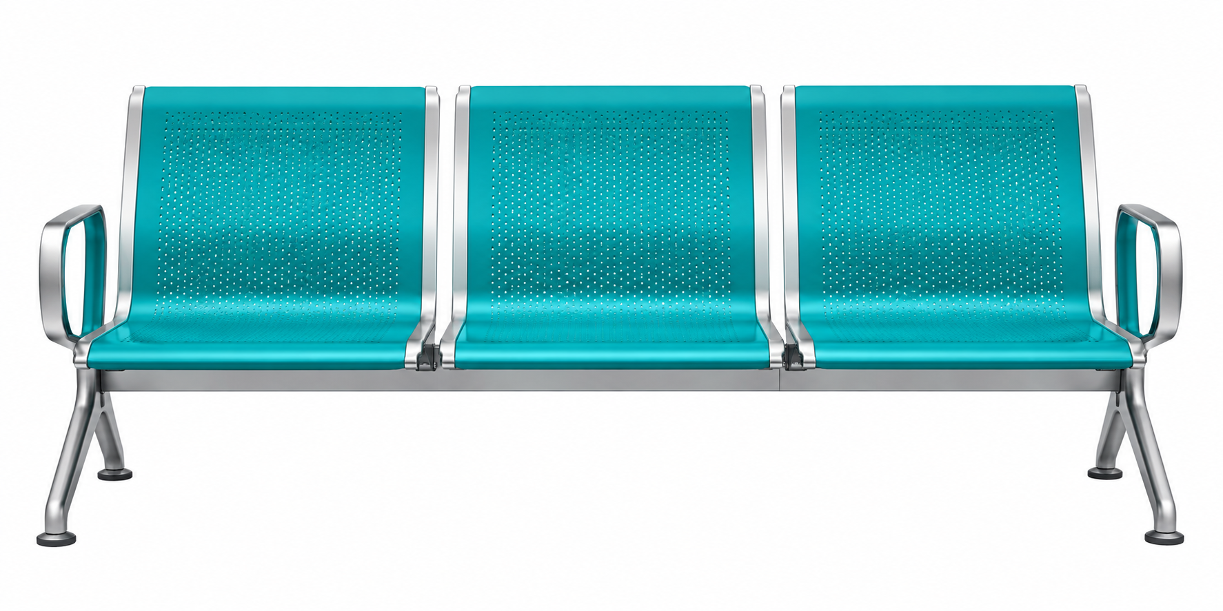  Product reference for a three-seat waiting-room bench

3.3 Target groups and service priorities
- Primary priority: children and their parents who are eligible within the IMSS Bienestar system.
- Secondary priority: people requiring urgent dental care within the same eligible population.
- During the initial phase, actual demand and attendance would be measured before expanding capacity.
- If participation is lower than expected because communities are geographically distant, transportation solutions or simpler outreach/mobile teams could be evaluated.

3.4 Staffing and operating costs
Sufi Service Committee Sweden could finance one dentist and one dental assistant, with the assistant also functioning as a coordinator where practical. If activity expands, a separate coordinator and/or an additional dentist could be added according to patient volume. The committee could also cover relevant insurance and defined operational costs.

3.5 Materials, records and security
- Additional dental materials could be financed by Sufi Service Committee Sweden but purchased through Salud’s procurement system, with joint participation in product selection where appropriate.
- An approved digital dental record and appointment system could be financed, including electronic documentation and registration using accepted identification documents, with future integration considered where compatible with national healthcare identification systems.
- The unit would operate under Salud’s security protocols and supervision.
- Sufi Service Committee Sweden could finance insurance and security cameras; the cameras could subsequently be handed over to Salud for routine management.
- Local social networks and community structures could be engaged through Salud to encourage community participation and stewardship.

4. Project B – Chronic disease program at UMAPS Corralejo
A second workstream would focus on improving structured management of chronic disease among already known patients, initially diabetes and hypertension, while also strengthening detection of COPD, which may be underdiagnosed in the local UMAPS population.
A substantial part of the development work could be organized remotely through collaboration between the Swedish clinic and the healthcare staff in Corralejo. Local treatment programs, clinical pathways and practical follow-up guidelines would be developed together and adapted to local resources and regulations.

4.1 Patient selection and follow-up
- Prioritize existing patients whose clinical parameters remain suboptimal but who demonstrate reliable treatment adherence.
- Explore whether Salud/UMAPS can generate appropriate patient lists in accordance with applicable data-protection and governance rules.
- Develop structured documentation templates for hypertension, diabetes and COPD.
- Use shorter, standardized follow-up visits for stable and well-controlled patients, allowing more clinical time to be directed toward patients with suboptimal control.
- Where permitted within local scope-of-practice rules, develop nurse-supported workflows for medication renewal after physician review/signature.

4.2 Home monitoring
For selected patients following medication adjustments, the project could purchase approximately 10–20 blood pressure monitors and glucose meters for temporary loan. This would support closer follow-up and help clinicians evaluate treatment response without requiring unnecessary clinic visits.

4.3 Medicines
The current medication lists could be reviewed jointly to identify important medicines that are unavailable or insufficiently available. Sufi Service Committee Sweden could explore charitable or reduced-price purchasing from recognized international wholesalers and manufacturers. Any purchasing or import process would require prior confirmation of Mexican legal, regulatory and procurement requirements, with Salud facilitating the appropriate institutional pathway where possible.
Medication support should be linked to structured follow-up and defined clinical criteria so that limited resources are directed to patients most likely to benefit.

5. Project C – Digital and physical infrastructure at Corralejo
- Replace four existing computers with more modern devices and larger, ergonomically suitable monitors.
- Investigate the technical feasibility of a fiber internet connection. If feasible and institutionally acceptable, Sufi Service Committee Sweden could cover the subscription cost so staff are not required to pay personally.
- Provide ergonomic chairs and desks where needed.
- Develop secure and practical workflows for remote professional collaboration, clinical education and follow-up.

6. Staffing capacity
According to the staffing structure previously described by Salud, a UMAPS serving approximately 3,000 inhabitants should normally have two nurses, together with the required medical staffing. UMAPS Corralejo serves approximately 5,000 inhabitants and currently appears to have one nursing position fewer than this organizational standard. The project therefore proposes that Salud confirm the applicable staffing requirement and assess the appointment of an additional nurse in connection with the launch of the pilot.
A time-limited motivational or incentive model for staff participation during the first year could also be explored, subject to Salud’s employment, ethics and compensation rules.

7. Roles and responsibilities
Area | Sufi Service Committee Sweden | Salud
Financing | Defined equipment, staff, insurance, materials, digital systems and agreed operating costs | Institutional authorization and agreed procurement/administrative processes
Clinical governance | Internal quality follow-up and collaborative guideline development | Healthcare license, supervision, credential validation, regulatory compliance and quality inspection
Staffing | May select/finance agreed project personnel | Validates credentials and determines institutional acceptability
Procurement | May participate in specifications and finance agreed purchases | Uses/approves appropriate procurement and regulatory pathways
Data & records | May finance approved systems and technical support | Defines permitted systems, access, governance and data-protection requirements
Community engagement | Supports logistics and project communication | Coordinates with local networks and community structures

8. Evaluation framework
The pilot should be designed from the beginning so that both costs and measurable effects can be evaluated after one year. The purpose is not only to assess whether the activities worked, but also whether the working methods can be sustained within existing resources or require additional budget.
- Dental: number and profile of patients treated, waiting time, treatment type, completion rates, urgent versus preventive care and community reach.
- Diabetes/hypertension: follow-up coverage, relevant clinical control measures, adherence to planned reviews and use of home-monitoring equipment.
- COPD: number of patients assessed, newly identified cases where appropriate, and implementation of structured follow-up.
- Digital capacity: connectivity, reliability of remote collaboration, documentation quality and staff usability.
- Resources: staffing time, equipment utilization, medicine/material expenditure and total project cost.
- Quality and safety: incidents, compliance with protocols, patient feedback and results of institutional/internal quality reviews.

9. Proposed next steps
- Divide the overall proposal into separate technical work packages: dental care, chronic disease, digital infrastructure, staffing, procurement/regulatory matters and evaluation.
- Confirm with Salud which elements can legally and institutionally be implemented under Salud’s license and which formal agreements are required.
- Obtain a current needs assessment from UMAPS Corralejo, including staffing, equipment, connectivity, patient volumes and available medication lists.
- Develop specifications and preliminary budgets for the dental unit, IT equipment, clinical monitoring devices and staffing.
- Define the patient eligibility criteria, documentation requirements and measurable first-year outcomes.
- Prepare the technical project for submission to the relevant Dirección de Planeación (Planning Directorate) and other required authorities.
- Establish an implementation timetable, responsibilities and review points before launch.

10. Longer-term perspective
If the pilot demonstrates good clinical results, appropriate demand, operational feasibility and responsible use of resources, Salud and Sufi Service Committee Sweden could evaluate expansion to other UMAPS. The mobile dental unit could be relocated according to regional need, while successful chronic-disease and digital working methods could potentially be adapted for other communities.
After the first year, Salud could assess whether the improved working methods can achieve the desired long-term goals within the existing public budget, whether additional allocation is needed, or whether continued complementary support from Sufi Service Committee Sweden would be valuable within the committee’s annual budget.

11. Closing perspective
Both parties have expressed a positive interest in exploring this collaboration. The intention is to build the project carefully, transparently and step by step, with Salud’s institutional authority and local knowledge combined with Sufi Service Committee Sweden’s financial and organizational support. The shared objective is to create a practical, measurable and sustainable pilot that can improve access and quality of care for communities in the San Miguel de Allende area.
Working document – for discussion and further technical, legal and financial development. All proposed clinical, procurement, licensing, data-management and staffing arrangements remain subject to approval by the relevant Mexican authorities and Salud.
Anoushe Sigaroudi
Sufi Service Committee Sweden
16 May 2026

